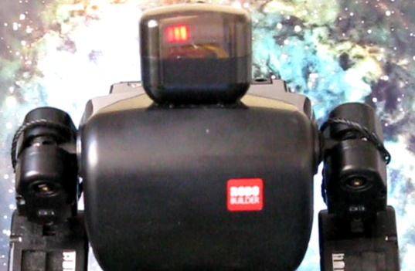
Controlling Robobuilder Humanoid robot using BASIC

If you want to give a gripper for your robobuilder, order it now from my Shapeways shop at http://shapeways.com/shop/ip_robotics.
And don’t forget to order a servo from Robosavvy to go with it.

Edition 1
Index
Introduction 3
Getting Started 4
Variables, Lists, Numbers 6
Controlling program flow 7
Using List 8
Controlling Servos 10
Dynamic control of a servo 11
Accessing IO and sensors 12
Accessing the low level hardware 13
SAMPLING Sounds and FFT 15
Controlling the robot 17
Continuous forward walking 17
How it works 17
Basic auto-balance 18
How it works 18
Mirror moves 18
How it works 18
Dynamic distance sensor 19
How it works 19
Access the Firmware 20
Modify RBC Serial Number 20
Using the BASIC IDE 21
Working with basic.exe 22
Using simulator 22
A’mazing 24
Concluding Remarks 26
Appendix A – Language Specification 27

Introduction

This document is a tutorial guide on programming a Robobuilder⁽¹⁾ series humanoid in BASIC. This gives Robobuilder the ability to create simple actions in an elementary basic language. The software is /beta release.
Basic.hex is an Open Source firmware BASIC interpreter running on the Robobuilder RBC unit written in C. Its for any one who would like to try programming - but are daunted by the complexity of writing in C - and yet want more than Action builder, download and try it out !!
Writing your first program couldn't be easier, after downloading the firmware and uploading on to the robot using the RBC upgrade tool, connect a terminal program such as hyper terminal or putty and reset the power. See figure 1. There is also a windows BASIC IDE application (.NET based) to simplify the download of programs. See later chapter for more details
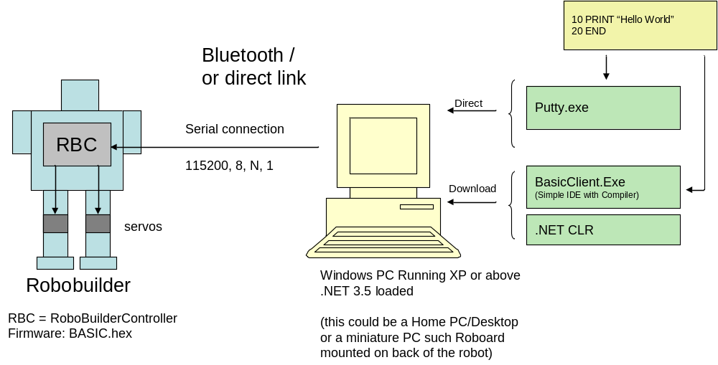
Figure 1
The firmware has 19 built-in motions to try out, including football kicks. Full access to all sensor such as PSD, accelerometer and IR port. It’s fast enough to program in continuous walking and auto balance.

Getting Started
Download basic.hex on to the RBC module using the RBCUpgrade tool as per Robobuilder manual pg 70. A windows OS build is available - basic.exe. it input/outputs using windows console. Robot hardware functions are stubbed out.
Turn on the RBC and connect a vt100 terminal emulator (such as HyoerTerminal or Putty). You should see the following:
Basic v=$Revision: 242 $
Commands: i r l c z q
16 servos connected
0 lines in memory
:
At the prompt type one of the following
- i - input a new program at start of line will exit input mode
- r - run current program press Red button on IR remote
- R - run in TRACE mode
- l - list current program
- c - clear memory
- z - download (requires client - see below)
- q - check servos connected
In input mode you get a '>' prompt, in command mode a ':'. In input mode a command with a line number is stored in flash - and will be there after you turn the robot off.
When entering program lines, if no line number is input, then the command will be immediately executed. Otherwise the line is stored in FLASH memory on the controller and remains there even after the RBC is turned off. A line that starts with a full stop ‘.’ and contains no other characters will exit input mode, and the colon ‘:’ prompt is displayed. The program can be run by entering an ‘r’ or by pressing the red square button on the IR remote control.
In the following example a simple two line program is entered, the Hello World example. Code generated by the firmware on the terminal is in blue, and code entered by the coder is in green.

Here is an example session:
Basic v=$Revision: 242 $
Commands: i r l c z q
16 servos connected
0 lines in memory
: i
Enter Program '.' to Finish
> print "hello world"
hello world
> 10 print "hello world"
> .
1 lines entered, [25/3072] Bytes
: l
List Program
10 PRINT "hello world"
: i
Enter Program '.' to Finish
> 20 goto 10
> .
1 lines entered, [28/3072] Bytes
: l
List Program
10 PRINT "hello"
20 GOTO 10
: c
Clear Program
This program will get into a recurring loop, and if this happens in your programs (either accidentally or deliberately) then just press 'Esc' on the PC keyboard. The program will terminate immediately and return to colon prompt and command mode. If that fails then hit the 'OFF' button (on the robot!)
Notice in the above example each time you enter input mode its adds to the current program. If you want to start over then press “c”. To run the program press 'r' (and then Esc!)
Also the lines follow numerically so if you want to insert a line between 10 and 20, just enter a number between 10 and 20 i.e. 15, and the new code will be added between those lines. If you want to edit a line just key in its number and the newline will replace the existing line.

Variables, Lists, Numbers
Variables
Only integer variables are allowed. Variables names are A-Z. Eg:
LET A=5
LET C=A+2
Expression and Operators.
Maths + - * \ ( ) %
Comparison = < > <= >= <>
Logic & |

Enter Program '.' to Finish
> print 5+3
8
> print 5*(2+2)
20
> print 5=6
0
> print 5=5
1
> print 6%4
2
> print 6/4
1
LET & PRINT
As you can see from the above expression Print displays the value of any expression, so we can now write a simple program. The LET assigns the value of the expression to a variable, and the PRINT outputs to the terminal the result (along with a text message.
10 LET A=(5+3)*(2+1)
20 PRINT "The answer is ";A
30 END
END
Program will stop if it reaches the END statement. It is not essential as there is a assumed END statement after the last line. Also you can have multiple END statements in a program if there are multiple exit points.

Controlling program flow
Simple loops

The simplest way to create a loop is using a GOTO statement followed by a line number. If a conditional flow uses the IF statement. It evaluates the expression and if true (i.e. evaluates to 1) will THEN jump to the line indicated, if false (evaluates to 0) it either continues to the next line or ELSE goes to the line indicated.
10 LET A=1
20 PRINT A
30 LET A=A+1
35 WAIT 500
40 IF A<10 THEN 20
50 END
This example loops printing the numbers 1-9 with a 0.5 second delay.

For Loops
10 FOR A=1 to 5
20 PRINT A
30 NEXT A
Generate random numbers
Also use % to get modulo of $RND - so example return 10 numbers between 0 and 5
10 FOR i=1 to 10
20 PRINT $RND % 6
30 NEXT I
Gosub and Return

10 PRINT "Hello";
20 GOSUB 50
30 PRINT " back";
40 END
50 PRINT " Here";
60 RETURN
Output:
Hello Here back

Using List
Simple LISTS

Although variables can contain only integer numbers, that number can be used as a pointer to a List. Lists are read-only and can contain numbers and expressions. lists are number from zero. First element is the length of the list
10 PRINT "List test"
20 LIST A=5,4,3,2,1,5
30 PRINT @a[1]
40 PRINT @a
Output:
3
4,3,2,1,5

Index through a list

10 LIST A=5,65,66,67,68,69
20 FOR I=0 to 4
30 OUT @A[I]
40 NEXT I
50 PRINT
output:
ABCDE
Dynamic lists

In this example the list contains an expression using variable ‘X’

5 LET X = 5
10 LIST A = 5,10+X,1,2,1,20-X
20 PRINT @A
30 MOVE @A,2,5
50 LET X = X+5
60 GOTO 20
Inline List @{}

PRINT @{2,4,5}
MOVE @{5,10+X,1,2,1,20-X},2,5

Access current List
@!

Access offset list
@#

List arithmetic
@A-@B or @A+@B
73 PRINT @{2,4,5}+@{3,1,2,3}
74 PRINT @{3,1,2,3}+@{2,4,5}

LIST based Functions

$MAX, $IMAX, $MIN, $NORM, $SUM

10 LIST a=16,12,6,0,0,0,0,0,0,8,4,7,0,0,0,0,2
20 LIST b=16,13,0,0,0,0,5,8,0,8,1,0,7,0,0,8,0
30 PRINT $max(@a)
40 PRINT $min(@b)
60 PRINT $norm(@a-@b)
70 SORT @a

$MAX return the value of the largest element. Also a function IMAX that returns the index of the largest element. You can also sort a list using SORT command

Access parts of a list

PRINT @{5,1,2,3,4,5}[2,3]
PRINT @{5,1,2,3,4,5}[2,7]

Sub list [a,b] creates a new current list from element a through to b. If b is passed end of list, end is assumed and a<b and a>=0.

Controlling Servos
Take up basic pose

Couldn’t be easier, this for Huno configured 16 servo bots. For those with a Hip kit and 18 or more servos use STAND 16.
10 STAND 16
There’s also a MOVE command for customised poses.
10 MOVE @{16,125,179,199,88,108,126,72,49,163,141,51,47,49,199,205,205},10,1000
Alternative shows use of the MOVE command with a literal/inline LIST to take up Basic pose. Note: There is one subtle difference with STAND in that its not affected by the OFFSET command where as MOVE is.

Run a built in motions

There are 19 built in motions that can be access directly using the RUN command. See Appendix A for list of built in motions
10 STAND 16
20 RUN $MAPIR($IR)
30 GOTO 20
Read and set servo
This reads current position of servo 12 and then moves and extra 5
10 LET a=$servo(12)
20 PRINT "Pos=";a
30 SERVO 12=a+5
Use of Passive mode
10 SERVO 12=@
20 PRINT "Servo 12 = "; $SERVO(12)
30 WAIT 500
40 GOTO 20
Changing Red/Blue IO port values
10 LET A=0
20 SERVO 12=~A
25 WAIT 50
30 LET A=A+1
40 GOTO 20
Output: Servo 12 will flash red/blue light (assuming its a transparent servo!)

Dynamic control of a servo
The Robobuilder humanoid robot can be extended with up to 32 servos (from the standard basic kit of 16). One way of extending is to add some form of gripper to enable the robot to pick up objects in its world. A simple gripper can be built in many ways; one way is to use a 3D printed object such as is available from Shapeways.Com. Here is an example of a couple available from Ipswich Robotics : Left gripper or Right gripper

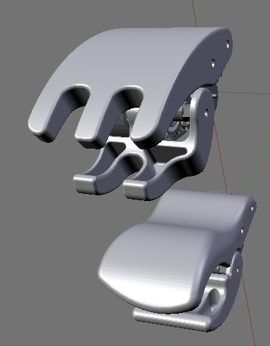
Top – New style gripper, Bottom original style

10 STEP 18=70,120,5
Assuming a gripper is connected to Servo 18 this function will slowly close the gripper until it either is fully closed or its movement is stopped by an object in it grasp.

Accessing IO and sensors
Read from console and IR port
10 LET A=$KBD
20 PRINT A
30 LET A=$IR
40 PRINT A
50 GOTO 10
Read accelerometer values
10 PRINT $TICK;" X=";$X;" Y=";$Y;" Z=";$Z
20 WAIT 500
30 GOTO 10
Read button pressed
10 LET A=$IR
20 PRINT "Received=";A

Lights proximity detector
10 LET P=$PSD
20 LIGHTS P-10
30 GOTO 10
The lights on the back of the Robot (Run,Pwr, Err) will act as a bar graph showing how close an object is to PSD sensor

Show PSD sensor output as a bar
10 out 45,$psd
20 out 42
30 print
40 goto 10
Output:
----------*
ASCII value '-' 45, '*' 42, and If $PSD value is say 10

Accessing the low level hardware
RBC unit I/O ports

Port/Pin | I/O | Description
PC7 | O | Power LED (Red)
PG2 | O | Power LED (Green)
PA7 | O | Error LED (Red)
PA6 | O | Run LED (Green)
PA5 | O | Run LED (Blue)
PA4 | O | PF2 LED (Orange)
PA3 | O | PF1 LED (Red)
PA2 | O | PF1 LED (Blue)
PA1 | I | PF2 Switch (High : Not pressed, Low : Pressed)
PA0 | I | PF1 Switch (High : Not pressed, Low : Pressed)

Reading PF1 and PF2
The buttons on the back of the RBC are normally logic high and go low when pressed. The are access via bits 0 &1 on PORTA -
10 PRINT "Press PF1 or PF2 to start"
20 IF ($port:a:0=1)&($port:a:1=2) THEN 20
30 PRINT "Done"
Note the use of the & for logic AND.
Switch LEDS on and OFF
The LEDs can be access via the PORT as well. Red Power LED is on Port C bit 7. This LED is on when bit is zero and off when bit is 1. So the following will flash the light
10 LIGHTS 0
20 PUT port:c:7=1
30 WAIT 500
40 PUT port:c:7=0
50 WAIT 500
60 GOTO 20

I2C Communication example(s)
This examples reads values from the optional accelerometer (address 112). The bytes are available from current array @![n]. Note use of $CVB2I() - converts the read bytes values to integers i.e. 255 -> -1.
10 FOR I=1 to 10
20 I2CO 112,@{1,2}
30 I2CI 113,6
40 PRINT "X=";$CVB2I(@![1]);" Y=";$CVB2I(@![3]);" Z=";$CVB2I(@![5])
50 WAIT 250
60 NEXT I
output:
X=5 Y=-2 Z=6
X=5 Y=-2 Z=7
...

SAMPLING Sounds and FFT
Sampling
The Microphone can be sampled into a LIST @< and processed including being converted into a spectrum using FFT command.

SAMPLE 5,5000,4,64

This loads a 64 element sample (Maximum size) into the area, but only if the audio level gets above ‘5’ with in the next 5000 ms (i.e. 5sec). Each sample is 4ms long.

The sample can be displayed by PRINTing the current list @!

Here’s an actual sampling

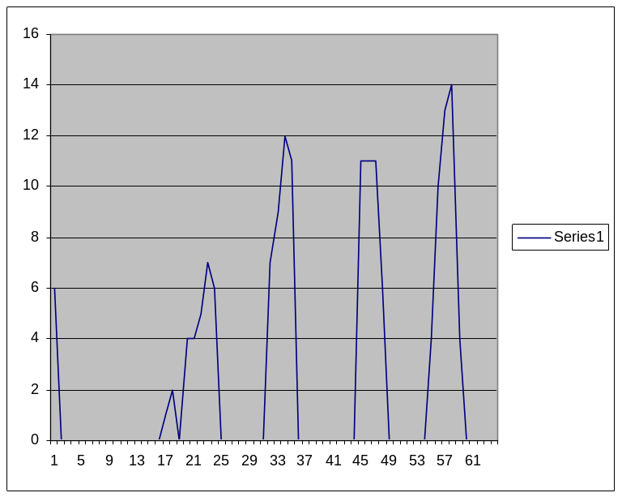

@{64,6,0,0,0,0,0,0,0,0,0,0,0,0,0,0,0,1,2,0,4,4,5,7,6,0,0,0,0,0,0,0,7,9,12,11,0,0,0,0,0,0,0,0,0,11,11,11,6,0,0,0,0,0,0,4,10,13,14,4,0,0,0,0,0}
FFT
Fast fourier transform converts time sample data into a frequency spectrum. Here is a test case where FFT is done on a single impulse. It will contain every frequency of equal amount.

FFT @{8,100,0,0,0,0,0,0,0},1

FFT from an actual speech sample
Result:
173,55,45,20,9,109,102,28,45,11,39,63,22,16,19,2,14,23,5,18,12,7,11,16,14,19,17,8,7,10,17,10,5,9,16,12,7,9,17,21,13,16,12,6,13,19,5,24,14,3,17,14,22,64,40,11,47,28,99,107,9,20,45,57

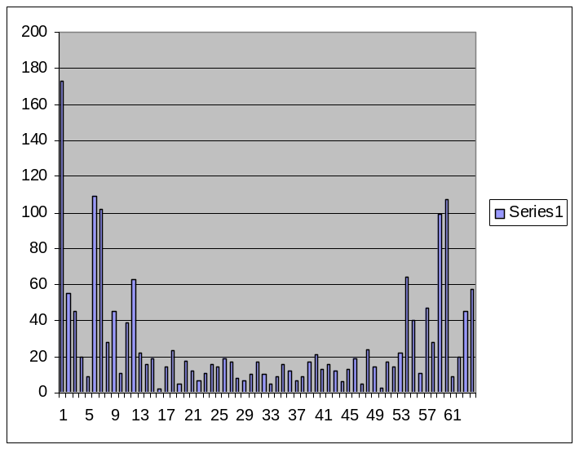

Notice firstly there is a big DC element and that the result is a mirror image about the centre is because the max freq is half the sampling frequency. So 4ms sample – maximum frequency is 250Hz. So each element of the array represents 250/32 Hz or 8Hz per sample. The two peaks being at 5 or 40Hz and 11 or 88Hz,

Access the elements

FFT @{8,0,10000,0,0,0,0,0,0}

FOR I=0 to 7

PRINT @![i]

NEXT I
Putting it into a program

210 PRINT "SAY SOMETHING"

220 SAMPLE 5,5000,4,64

240 FFT @!

260 GOTO 210

Controlling the robot

Continuous forward walking
5 STAND 16
10 PRINT "press any key start"
15 LET K=$kbd
20 LET A=25
30 PRINT "R";
35 MOVE @{16,123,156,212,80,108,126,73,40,150,141,68,44,40,138,208,195},1,A
40 MOVE @{16,130,165,201,81,115,134,81,31,147,149,72,44,40,145,209,201},1,A
45 MOVE @{16,132,171,197,83,117,137,86,28,148,152,78,43,41,154,209,206},1,A
50 MOVE @{16,132,175,195,87,117,139,91,27,152,154,87,43,43,164,209,211},1,A
55 MOVE @{16,132,178,197,91,117,137,95,28,157,152,97,43,48,172,209,213},1,A
60 MOVE @{16,130,179,201,95,115,134,96,31,161,149,105,43,53,179,210,214},1,A
65 MOVE @{16,127,178,206,98,112,130,95,35,166,145,111,42,57,182,210,214},1,A
70 MOVE @{16,124,175,212,100,109,127,92,40,170,142,113,42,59,183,210,214},1,A
75 PRINT "L";
80 MOVE @{16,124,175,212,100,109,127,92,40,170,142,113,42,59,183,210,214},1,A
85 MOVE @{16,120,172,217,102,105,123,88,46,170,138,111,42,57,182,210,214},1,A
90 MOVE @{16,116,167,221,103,101,120,83,51,169,135,106,43,53,179,210,214},1,A
95 MOVE @{16,113,162,224,102,98,118,77,55,167,133,97,43,48,173,209,213},1,A
100 MOVE @{16,111,157,225,98,96,118,73,57,163,133,87,43,43,164,209,211},1,A
105 MOVE @{16,113,153,224,93,98,118,70,55,159,133,79,43,41,154,209,206},1,A
110 MOVE @{16,116,152,221,89,101,120,69,51,155,135,72,44,40,146,209,201},1,A
115 MOVE @{16,120,153,217,84,105,123,70,46,152,138,69,44,40,140,208,197},1,A
120 MOVE @{16,123,156,212,80,108,126,73,40,150,141,68,44,40,138,208,195},1,A
125 GOTO 30

How it works
Line 5 STAND - instructs the robot to take up basic posture. line 15 causes the program to wait for a key press - you could alternatively make it wait for IR remote by switch $KBD for $IR.
Line 35 move @{...},1,A moves servos from their current position to the new position, as specified in the list @{...}. First number is length of list i.e. 16. There are two other parameters, the '1' is the number of increments to take and the 'A' is a variable containing 25, the total length of time i.e. 25ms. You can vary A or switch for a constant etc...
Line 125 GOTO will cause the program to loop for ever (or until 'Esc' is pressed on keyboard). Line 25 and 70 produce 'RLRL... etc on the serial port.
To run type 'r'. in command mode ':' prompt or the red square on IR. The program is in flash so its still there even after being turned off. Just turn back on and press the red button ! (you'll need to switch the KBD for IR first - or it after standing it will wait for keyboard input)
Lots of mods to expand this are possible. The program could check for $PSD value or check, or see if its fallen over, by testing the accelerometer $X / $Y or $Z. You can vary the speed by changing the value 'A' -etc ...

Basic auto-balance
10 STAND 16
20 Print "Press any key"
30 if $kir<0 then 30
40 list m=7,-4,-2,-1,0,1,2,4
50 Let d=$find($z, @{7,-15,-10,-5,0,5,10,15}
60 let o=@m[d]
70 wait 10
80 print $z;"-";d;"-";o
90 servo 10=$servo(10)+o
100 servo 13=$servo(13)-o
110 wait 10
120 if $kir<0 then 40

How it works
Line 10 causes the robot takes up Basic pose. Line 30 make it wait until keyboard or IR input. Line 40 set up list of offset values. Lines 50 maps the output of the z axis of the accelerometer ($z) to a range using the $find function. Line 60 then translates that into a displacement to apply to the servo. In lines 90 and 100 it updates the current position of the servo $servo(x) with the offset o. Line 120 cause the program to loop until either keyboard or IR remote is pressed ($kir) is received. If -1 it means no input.

Mirror moves
Run the program and then move the right arm - and watch the left arm follow!
5 stand 16
10 servo 13=@
20 servo 14=@
30 servo 15=@
40 print "ready"
50 if $kir<0 then 50
60 let a=$servo(13)
70 let b=$servo(14)
80 let c=$servo(15)
90 servo 10=254-a
100 servo 11=254-b
110 servo 12=254-c
120 wait 50
130 goto 60

How it works
The program first lines 10-30 puts servos 13,14,15 into passive mode, this makes them free to move. These servos form the right arm of the robot. It then loops reading their current position on line 60-80. Its then moves the left arm by corresponding amount. Because the left arm servos are reverse they move in the opposite direction, hence the 254-a.

Dynamic distance sensor
The arms dynamically move as the distance sensor detects your presence !!
10 stand 16
20 servo 13=200
30 servo 10=50
40 let a=$psd
45 print "Psd=";$PSD
50 servo 13=250-a
60 servo 10=a
70 wait 200
80 goto 40

How it works
The value of the PSD sensor (always between 10 and 50) is used to set the position of servo 10 and 13 (the shoulders). These will move in unison based on the value. If nothing in range PSD will return 50, so servo 13 is set at 200 and servo 10=50, whilst at closet approach PSD will be 10 and Servo 13=240 and servo 10=10.

Access the Firmware

Modify RBC Serial Number
Some times the firmware can get corrupted and the serial number is lost. When this happens the standard firmware won't download programs from the internet as they won't match the serial number. So to inspect the firmware you need to read the Flash memory using the $ROM() function. Type 'i' and enter the following program:
10 FOR I=1 to 13
20 OUT $ROM(I);
30 NEXT I
40 PRINT
If you see 13 digits all is well. If not find your serial number (its printed on the RBC unit) and update the ROM from interactive /input mode using for example:
ROM 1,48
ROM 2,49
etc ...
This will set the first digit to ASCII 48 or '0', second to '1' etc ... (Sorry you will have to covert your s/n to ASCII yourself - hint is 48 + digit 0-9?
Use this with CAUTION !!!!!
Basic programs are stored in flash - it will overwrite any action or motion scripts you have created. If / when you revert to standard firmware you will need to reload them.
It is possible (hopefully unlikely) that if the firmware goes wildly wrong it could overwrite your serial number and/or zero positions - these are recoverable but with some effort (see above)

Using the BASIC IDE
A windows based editor and compiler to simplify working with Robobuilder Basic programs. The Basic firmware can work directly with all that is needed being a terminal program, however the client does make transferring programs from PC to Basic much simpler, and enables storage of programs and increase readability of programs.
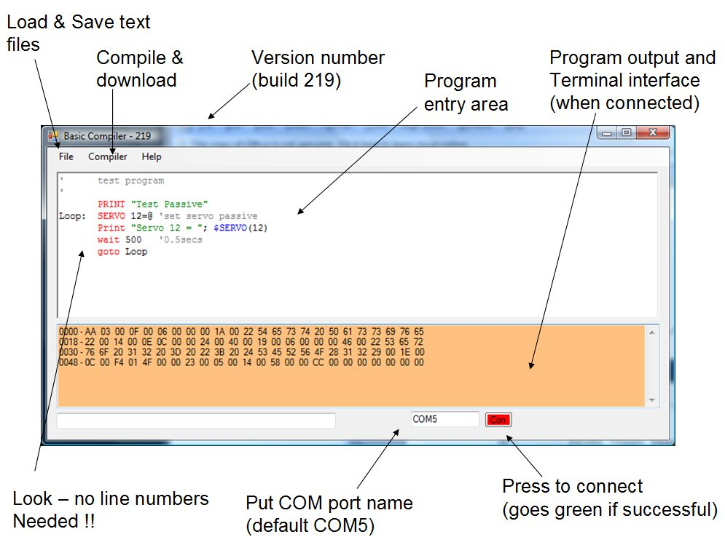
Figure 1
The upper window is a standard text editor. Note it auto-generates line number and allows the use of labels (unlike the firmware version).
The bottom windows shows the output of a compile. This can be transfered to the robot by connecting via a serial link - use the red button (edit COM5 to be the port you use).
The windows is then an interactive console on to the robot. Press z (to put robot in download mode) and then select download from the menu. The program will automatically compile if not already been performed.
Key advantages of client
- enable programs to be stored on PC and transfered to robot when required
- auto generates line numbers (int increments of 5)
- allows comments to be added (using ' )
- allows labels
- provides context sensitive colour coding
- allows multi-line if/then/else/endif statements
- allows const definition
- has a RBC simulator mode for programs in conjunction with basic.exe

Working with basic.exe
When a program is compiled a file bindata.txt is created - and this file can then be loaded into basic.exe using 'z' option. It will also be automatically loaded into basic when it starts.
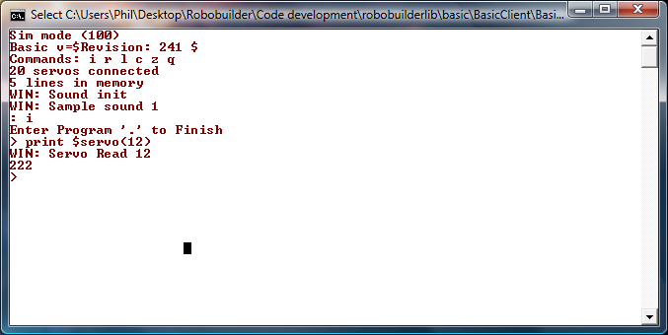
Figure 2

Using simulator
The simulator enables BASIC programs to be tested before being downloaded to RBC. The simulator can :
• Show output of any servo id 0-24
• Show the IO State of any servo
• Allow any servo value to be changed in realtime
• Read/Modify the X, Y and Z values of accelerometer
• Read/Modify the PSD
• Allow IR remote values to be set

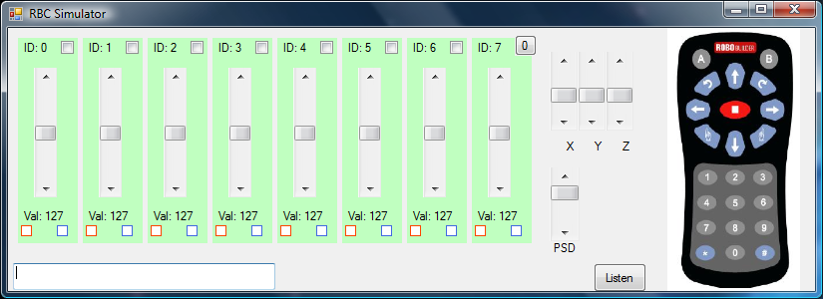
Figure 3
To use the simulator with basic.exe do the following:
1. Start simulator from menu
2. Press listen button to start server
3. Start basic.exe - it will show "Sim Mode" if able to connect

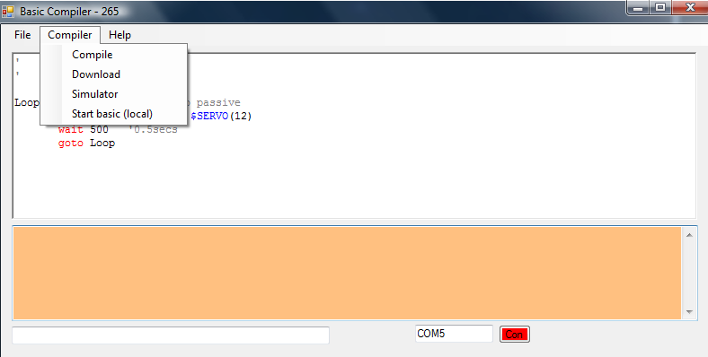
Figure 4

A’mazing
In the Robobuilder C programming tutorial there is an application written in C to enable the robot to traverse a maze using the distance sensor. You have to compile it in AVR C and download to the RBC. To make this easier to do, I've converted it to BASIC using the IDE.
The code builds uses the distance sensor to identify the walls and then the following algorithm:
1. If there is no wall, move forward.
2. If the wall is detected, then check left side.
3. If front and left side wall are detected, then check right side.
4. If front, left and right side walls are detected, go back the opposite way.
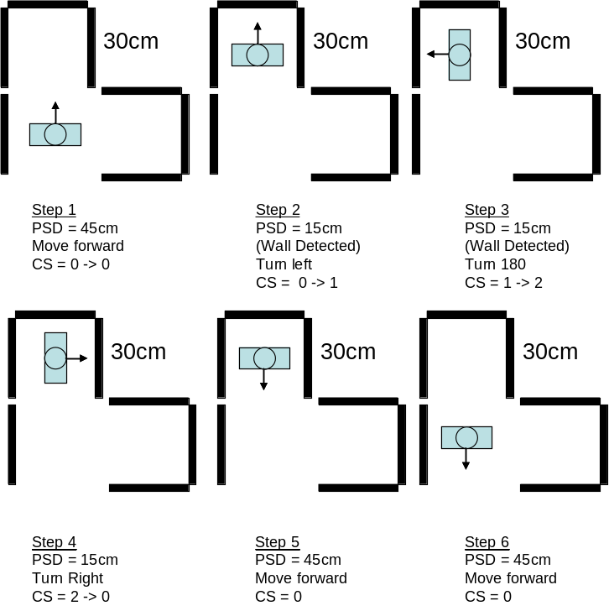
Figure 4

'Example maze program  'Based on Robobuilder C tutorial  stand 16  print "Maze Program"  let c=0  loop:  let d=$psd  lights d-10  if d < 12 then  gosub back  goto loop  endif  if (c = 0) & (d < 30) then  gosub leftturn90  let c=1  goto loop  endif  if (c = 1) & (d < 30) then  gosub leftturn180  let c=2  goto loop  endif  if (c = 1) & (d < 30) then  gosub rightturn90  let c=0  goto loop  endif  let c=0  gosub forward  goto loop | back:  print ":"  run 9  wait 1000  return  leftturn90:  print "<-"  run 4  run 4  run 4  wait 1000  return  leftturn180:  print "V"  run 4  run 4  run 4  run 4  run 4  wait 1000  return  rightturn90:  print "->"  run 5  run 5  run 5  run 5  wait 1000  return  forward:  print "^"  run 8  run 8  run 8  wait 1000  return

Concluding Remarks

- BASIC.hex and Wiki information is available from http://code.google.com/p/robobuilderlib/

- Code examples are available from http://code.google.com/p/robobuilderlib/source/browse/#svn/trunk/examples

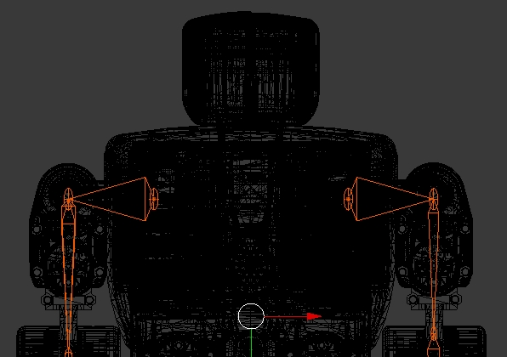

Appendix A – Language Specification
Language Spec:
VAR A-Z (integer only)
OPER + - * \ ( ) = < > % <= >= <> & |
CMD LET:FOR:NEXT:GOTO:IF:THEN:ELSE:PRINT:END:SET:RUN:POKE
WAIT:STEP:PUT:SERVO:MOVE:GOSUB:RETURN:LIST:STAND:OUT
I2CI:I2CO:OFFSET:SPEED:MTYPE
STRING " ... "
EXPR1 VAR | LITERAL
EXPR2 EXPR1 | STRING
LIST EXPR2 [,EXPR2]
EXPR EXPR1 OPER EXPR1
SYNTAX:
[LINE no] LET VAR '=' EXPR
[LINE no] GOTO [Line No]
[LINE no] PRINT LIST [;]
[LINE No] END
[LINE no] IF EXPR THEN LINE no ELSE Line No
[LINE No] FOR VAR '=' EXPR 'To' EXPR
[LINE No] NEXT VAR
[LINE No] WAIT number
[Line No] SERVO ID=EXPR | '@' | '~'
[LINE No] LIST [VAR]=N,1,2,3 ..
[LINE No] MOVE @[VAR],100,20
[Line No] GOSUB [Line No]
[Line No] RETURN
[Line No] STAND [16 | 18]
[LINE No] PUT VAR '=' $PORTA|B|C:0-7
[LINE No] OUT EXPR,EXPR
[Line No] RUN number
[Line No] PLAY number
[Line No] OFFSET [# | List | "blank"]
[Line No] IC2O number,List
[Line No] IC2I number,number,List
[Line No] SPEED number
[Line No] MTYPE number,number,List
[Line No] STEP ID=number,number,number

Command | Description
SERVO ID=POS | set servo id to position POS / @ / ~
LIST/MOVE | sends a Scene - 'n' Servo Positions, Plus time, no frames
POKE 10,A | Put A into Byte 10
PUT PORT:A:8 = 3 | set DDR of Port A = 3 (PIN0,PIN1 readable)
PUT PORT:A:2 = 1 | set Port A bit 2 =1 (assuming writeable)
WAIT 200 | Wait for a an amount of time in ms i.e. 200ms
STAND 16 | set servos to basic posture (for 16 or 18 servo bots)
OFFSET | Defines a numeric offset array to be applied to MOVE and PLAY commands
I2CO 51,@{3,1,2,3} | will send 3 bytes to I2C address 51
I2CI 52,5,@{2,1,1} | will read 5 bytes from address 52 after first send 2 bytes (1,1) to the same address.
SPEED 2 | Speed torque setting on Move 0-4 (0 maximum, 4 minimum)
MTYPE 3 | Set Motion type 0: Acc, 1=Deacc, 2=AccDeac?, 3=Linear
STEP 5=30,50,5 | STEP servo 5 from position 30 to position 50 in increments of 5 checking progress and stopping if obstruction
RUN 0 | Call Built in action using code i.e. RUN 0, would punch left  Built in motions:  0) PunchLeft  1) PunchRight  2) SidewalkLeft  3) SidewalkRight  4) TurnLeft  5) TurnRight  6) GetupBack  7) GetupFront  8) WalkForward  9) WalkBackward  10)lshoot  11)rshoot  12)rsidewalk  13)lsidewalk  14)standupr  15)standupf  16)sitdown  17)hi  18)kick left front turn
LIGHT n[,@list] | Show value ‘n’ in LIGHTS
SORT @List | Sort list numerical ascending
FFT @List,scale | FFT @list (scale to value)
SAMPLE a,b[,c[,d]] | A= trigger level, b=timeout value in ms, c= sample rate, d samples (64 is max)

Expressions can include “Special Registers” i.e LET A=$X+5 would set variable A to the current value of the X axis of the accelerometer plus 5.

Special register access ($) | Description
$X, $Y, $Z | accelerometer values
$IR | wait for IR remote and get button pressed LET A=$IR
$KBD | wait for keyboard press
$KIR | Scan keyboard and IR port return immediate -1 if nothing pressed
$PSD | PSD sensor value
$VOLT | Battery voltage
$TICK | Number of tenths of a second
$PORT | Read Bit 6 of Port A .. LET A=$PORT:A:6
$RND | Random numbers - different number each time called
$MIC | Microphone level
$TYPE | Number of servos i.e. 16
$SERVO(id) | position of servo id, i.e. LET A=$SERVO(5) get Servo ID 5 position
$ABS(x) | Absolute value of x returned
$ROM(x) | Contents of ROM location x, i.e. LET A=$ROM(10)
$MAPIR(x) | Maps value from IR to built in action code
$FIND(x, @A) | Look for item less than or equal to X and return index
$CVB2I(x) | Converts byte to int, i.e. 4 -> 4 and 254 -> -2
$NE | Number of elements in a list
$NS | Number of servos detected
$MAX / $IMAX(@A,n) | $MAX element (or index of) in list from position N
$SUM | Sum of lements
$NORM | Normal of a list
$MIN | $MIN element in list
$SQRT | Integer Square root 25 -> 5
$SIN | The integer SIN of angle – (0-255) represent 0-2Pi result ranges between +32,768 and -32,767 (representing +1.0/-1.0)
$COS | COS (see above
$HAM | Calculate hamming distance (TBD)
Bottom of Form

